

Organization or Company:

Individual Name:

Street Address:

City/State/Zip:

Phone:

Mailing Address (if different from above):

1. Location Requested:

2. Hours of Operation:

3. Vendor Category (please check only one):

___Food ___Flowers ___Artist/Craftsperson
___General Merchandise ___ Holiday/Seasonal

4. Complete description of product or service to be sold/displayed.

5. Period: 30 days_____ 60 days_____ 90 days_____ 180 days_____ One year____
($20.00) ($40.00) ($60.00) ($75.00) ($100.00)

6. Cost range of items to be sold:

7. Description of cart, display or equipment to be used:

8. Be sure to attach a photo or rendering, showing the dimensions, colors and materials of the cart or stand to be used - limited to 10’ long x 6’ wide x 8’ high. This information must be provided for review.

9. Person in charge of cart (if different from above):

Name:

Address:

City/State/Zip:

Phone:

I have read and understand the guidelines for Street Vendors, by which I will agree to abide as a Street Vendor within B-4 District of downtown.

Applicant’s Signature Date

Please return the completed application (including all drawings, photos, etc.) to:

Downtown Development Authority
401 Edwards Street, Suite 205
Shreveport, LA 71101

Phone: (318) 222-7403
Fax: (318) 222-3731

Cart: All merchandise must be sold from a professionally constructed, wheeled, movable cart.

Wheels must be air filled with a minimum diameter of eight (8) inches. Castors are not considered wheels and are not allowed.

The main body of the cart must be metal or wood.

Towed rubber tire carts must have fender skirts. Trailored carts with large, spoked, wooden or rubber wheels do not require fenders.

The top portion of the cart (canopy) must be canvas or standing seam metal and cover the majority of the cart. (Asphalt and wood shingles are prohibited.)

Cart Size: The cart shall not exceed the following dimensions: six (6) feet wide x ten(10) long x eight (8) feet tall (as measured from the sidewalk to the highest point of the canopy.)

Cart Colors: The cart shall have a maximum of three colors. Dayglow and fluorescent
colors are prohibited.

Cart Lights: If electric lights are incorporated into the cart, the light source must be a steady light. Flashing or blinking lights are prohibited. Lighting must be indirect (concealed).

Hitches: Trailer hitches should be concealed. (Optional)

Signage: All signs, pictures and graphics must be in visual harmony with the cart. Giant signs which are not in proportion to the cart will not be permitted. Menu boards must be printed and incorporated into the design of the cart.
(In other words, hand-made signs are not allowed.)

Cooking: Warming bins are allowed. Waste is to be contained on the cart and disposed of outside of the district. Deep fat fryers are prohibited. All food preparation must comply with Caddo Parish Health Department guidelines.

Design Cart designs must be submitted to the Sidewalk Vendor Committee for
Review: approval. All applications shall include the following items:

- Drawings of the cart showing length, width and height. Drawings shall
show menu boards, signage and graphics accurately.

- Drawings must be drawn to the scale of 1 inch = 1 foot. (1” = 1’0”)

- Drawings must depict the colors of the entire cart.

- If any of the above items is not submitted the application will be
rejected because of lack of information.

- Color photographs may be accepted in lieu of drawings. If photographs
are used, the following photographs must be submitted:

- Side view: Showing entire length and height.
- End view: Showing entire width and height.

Merchandise: The merchandise to be sold shall include:

Food: The sale of food for immediate consumption.

Arts and Crafts: Original items which are personally crafted or
one-of-a-kind. Garage sale or flea market type items
are not acceptable.

Other Merchandise: Any easily transportable, non-second hand item that
can be transported on and merchandised from the cart. Pornographic materials are prohibited.

Flowers: Real, silk or potted plants.

Holiday/Seasonal : The sale of or exhibition of products or services in
keeping with a “holiday” or seasonal theme. Vendors
in this category will be required to operate on a 5 day
a week basis for a minimum time period of 2 weeks and
may operate for a maximum time period of 4 weeks.

Attire and Vendors will be expected to behave and dress in an appropriate manner. Casual
Conduct: clothing, such as slacks, Bermuda length shorts, shirts, standard t-shirts, dresses
and skirts are acceptable. Bathing suits and tank tops are unacceptable.

Locations: Food vendors may not operate in front of a restaurant.

Merchandise vendors may not operate in front of a retail store that offers
competing goods. The committee shall determine if the goods are competitive.

New locations must be at least 50’ away from the nearest part of a
restaurant, cart or sidewalk cafe.

In situations where a vendor has established a permitted location, and
the adjacent restaurant owner desires to open a sidewalk café that would
incorporate the vendor’s location, the vendor will be permitted to operate
until the expiration of their permit. Upon the vendor permit’s expiration,
the restaurant owner will be allowed to open their sidewalk café in
accordance with the City’s Sidewalk Café Regulations. The vendor will be
required to relocate according to the sidewalk vendor ordinance.

No more than two of any one kind (i.e. hot dogs, hamburgers, pretzels, etc...)
will be permitted on one block face during any one time period.
*Note: The Texas Street promenade at Commerce shall be considered a block face.

Locations must leave at least a minimum of 10 feet of unobstructed
pedestrian space between the street edge of the cart and the curb on Texas,
Milam and Commerce Streets. On cross streets and other locations, a
minimum of five feet must be provided between the street edge of the cart and the curb. (As pedestrian activity is observed, Sidewalk Vendor
Committee has the right to amend this section.)

Carts are not permitted to operate on the curb line. Pedestrian space shall
be provided from the curb line to the cart.

Special exceptions may be made where granting a license is or is not expected
to cause a pedestrian or traffic hazard.

Vendor permitting shall not be allowed on contracted or designated festival
sites and the sidewalks adjacent thereto, in Riverfront Park and on the Barnwell Center grounds. Vendors whose regular permitted location is included within or adjacent to the boundaries of a temporary festival site must not operate during the festival without the consent of the festival organizer.

Carts and other temporary service devices must be removed from the
sidewalks and stored off-site when not in operation.

Operation With the exception of Commerce Street, Monday through Friday
Hours: 7:00 a.m. and 2:00 a.m.

Unlimited hours on Commerce Street.

Hours of operation are subject to further review.

Days: With the exception of Commerce Street, where vendors are required to
be present at their locations at least eight days (or nights) per month,
vendors are required to operate their carts at least 15 days per month.

Sidewalk The vendor committee shall meet to set guidelines and approve or
Vendor reject proposed guideline revisions and approve variances. If a license is
Committee: denied by the DDA and the vendor chooses to appeal the denial, the
committee will serve as the first level of vendor appeal. If the vendor
committee denies the license, the vendor may appeal to the Shreveport
City Council.

DDA Staff: Reviews and approves or denied application and submits to city for
permitting when application is complete.

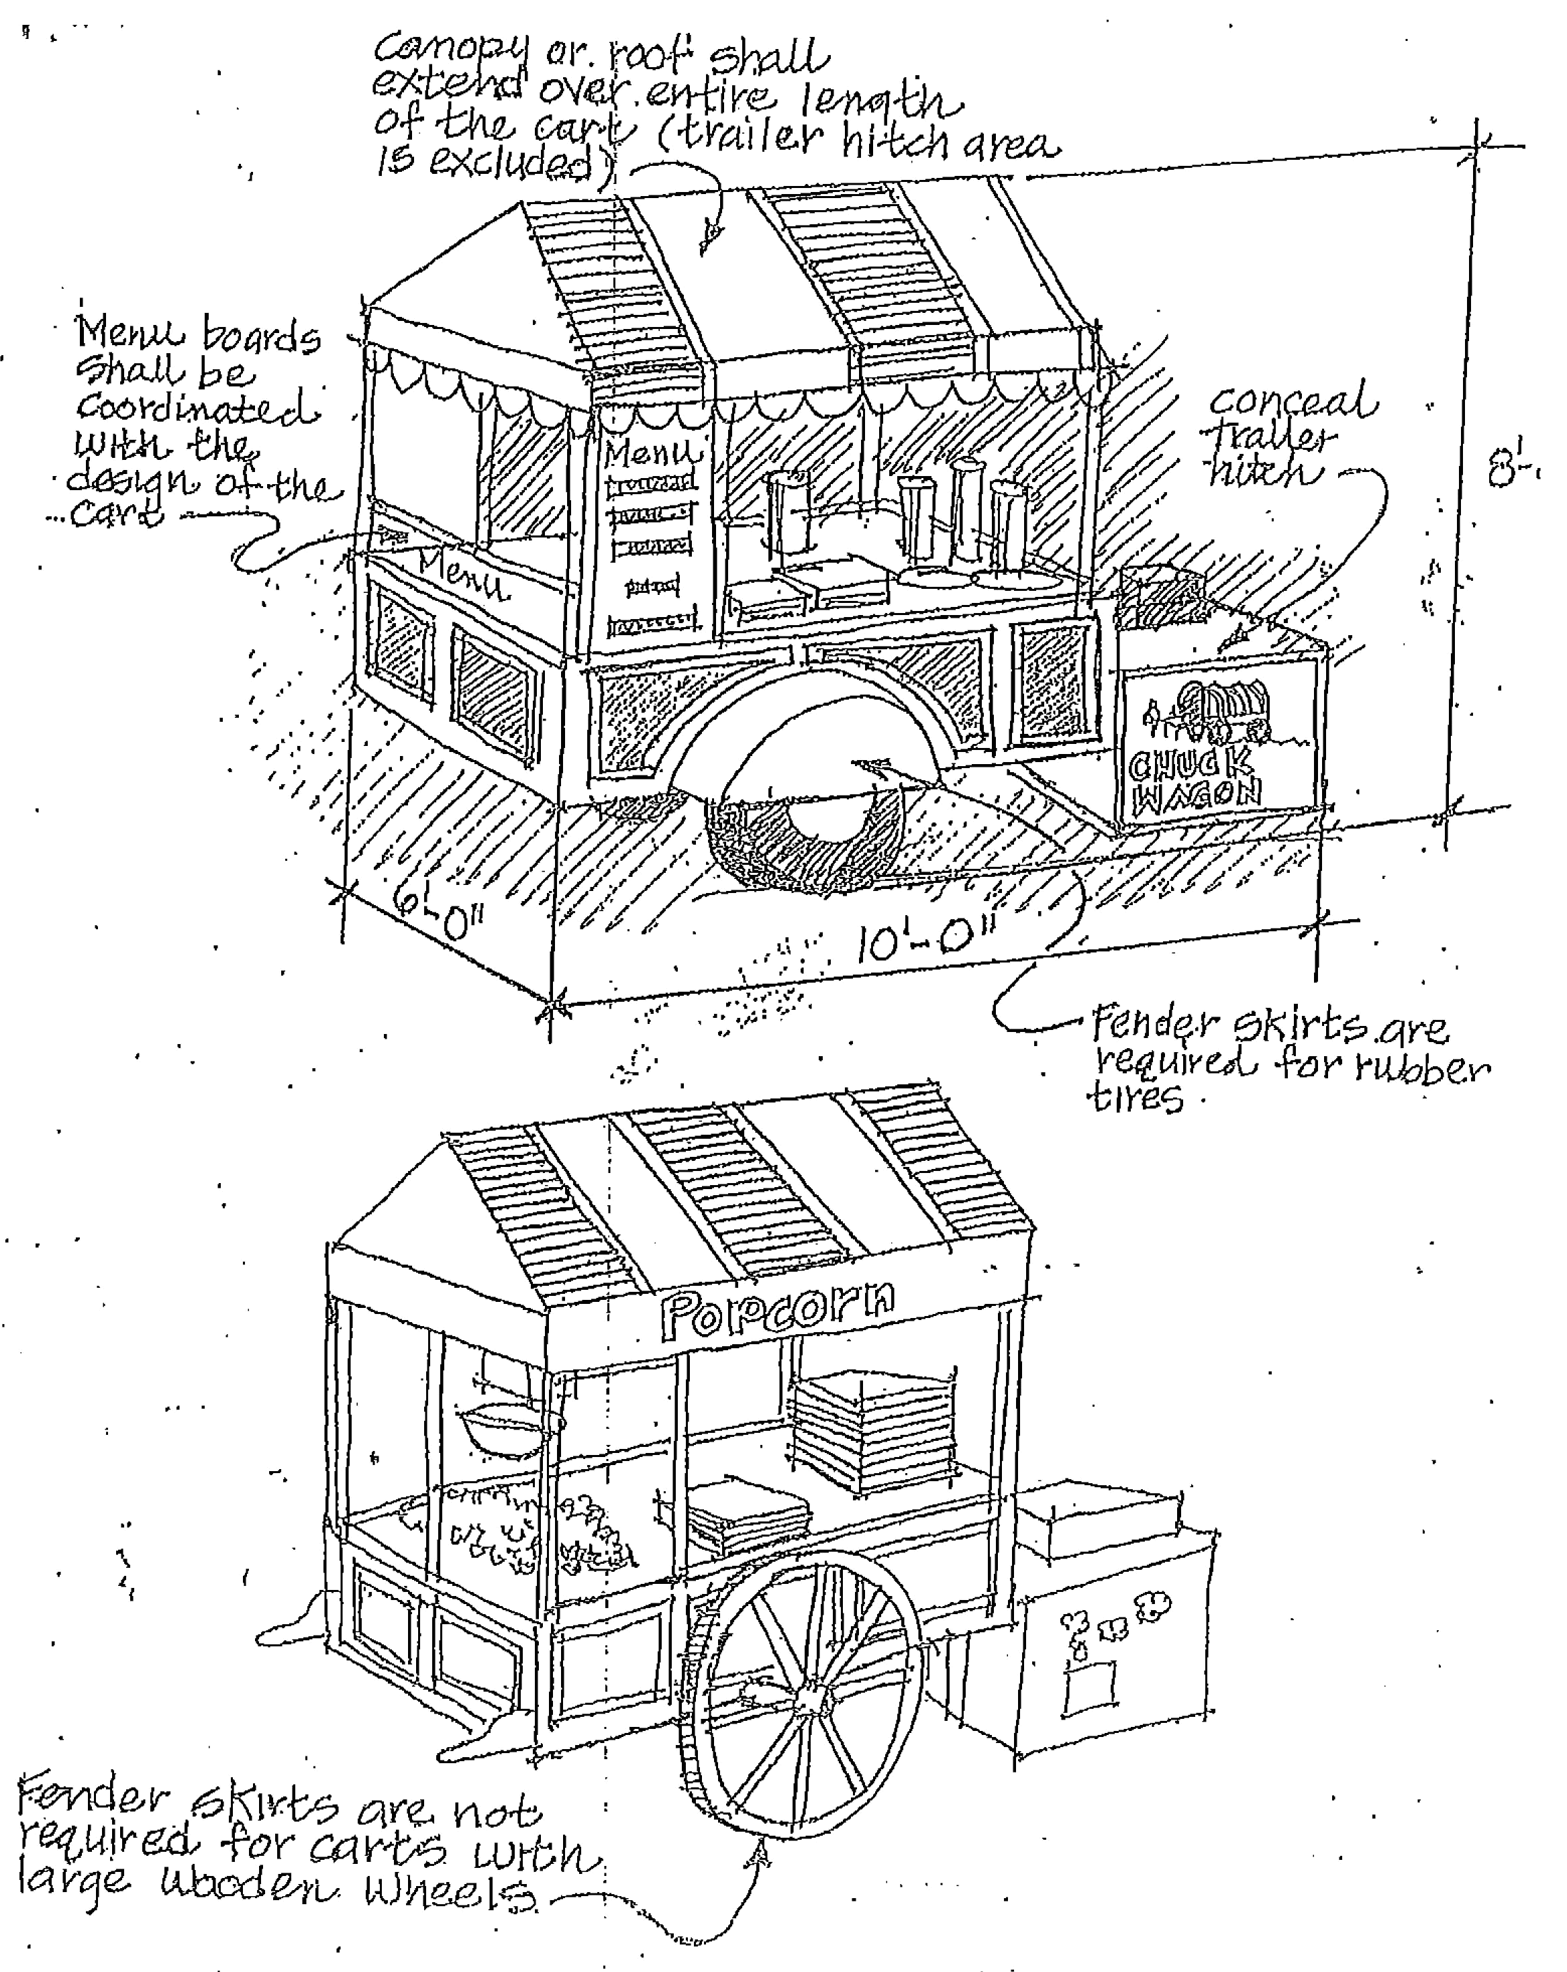

WHEREAS, the undersigned has made application for a Sidewalk Vendors License in the City of Shreveport,

NOW, THEREFORE, in consideration of the privileges and license granted by the City of Shreveport the undersigned hereby agrees to indemnify and hold harmless the City of Shreveport, its elected officials, officers, employees and agents from and against any and all claims, demands, suits, judgments and sums of money to any party accruing against the City of Shreveport, its elected officials, officers, employees and agents for loss of life or injury or damage to persons or property arising out of or in connection with the operations or licensing of the undersigned.

This agreement executed this _______ day of _____________________, _____.

WITNESSES: SIDEWALK VENDOR

Signature

Title

Name:

Address:

City/State/Zip:

Phone:

Location Number:

Vendor Cart Design Guidelines

Acceptable Unacceptable
□ □ Renderings or photos
□ □ Size (6’ wide x10’ long x 8’ tall)
□ □ Colors (no more than three)
□ □ Lights (non blinking, indirect)
□ □ Signage (integrated into design)
□ □ Construction (high quality of metal or wood)
□ □ Wheels (All wheels must be air filled with a minimum diameter of 8”.)

Merchandise/Activity

Acceptable Unacceptable
□ □ Food
Describe:
□ □ Flowers
□ □ Arts & Crafts
□ □ General Merchandise: Describe:
□ □ Street Performance
□ □ Holiday/Seasonal

Vendor Location Description:

Ordinance Requirements

Acceptable Unacceptable
□ □ Insurance: $1,000,000 liability. Attach proof.
Risk Management – 318-673-5540

□ □ Executed Hold Harmless Agreement

□ □ Certified copy of charter if the sidewalk vendor is a corporation of the state of Louisiana.

□ □ Certified copy of the permit to do business in the state if the vendor is a corporation incorporated under the laws of some state other than Louisiana. state if the vendor is a corporation incorporated under the laws of some state other than Louisiana.

□ □ Caddo-Shreveport Sales and Use Tax Commission registration certificate – 318-865-3312
State Taxes – 318-676-7515

□ □ Occupational License or certificate of
Exemption – 318-673-5500

□ □ Acknowledgment of Receipt of Vender Ordinance
and Guidelines ________ initials

Vendor Location Number Issued by DDA:

Form Completed and approved by: DDA Representative Date

This form will be completed by the Downtown Development Authority in accordance with the City of Shreveport’s Sidewalk Vending Ordinance. The completed form should be submitted with the application to the:

City of Shreveport Permitting Office
505 Travis, Room 130
318-673-6100

For more information contact:

Downtown Development Authority
318-222-7403

