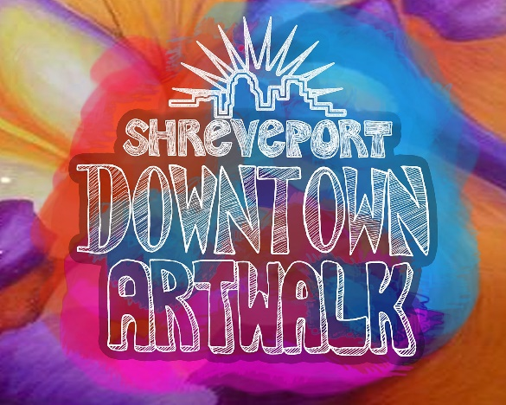

Name of Business: | Name of Business Owner:
Street Address | Town & Zip
Email | Phone (cell)
Website Address/Facebook Page/Other Social Media Pages | Do you have a current business license?

Briefly describe your business concept and inventory. What products do you intend to show/sell?
___________________________________________________________________

___________________________________________________________________

___________________________________________________________________

___________________________________________________________________

___________________________________________________________________

___________________________________________________________________

- Are all of your products appropriate for all ages? If not, please provide details.

- Include a brief biographical summary of yourself, professional work, community work and any other information that can be used to promote you and your work. (Attach to application if necessary)

- Do you agree to help promote the ARTWALK on social media and by sharing information about it with friends and customers?

- REQUIRED Attachment:
- Several high quality images of the art/products you wish to show/sell. Additional images and information may be requested. Please email all digital images to dda@downtownshreveport.com.

As a participant in the Downtown Shreveport ARTWALK, I consent to images related to this project being used for promotion of the program and downtown by Downtown Development Authority. This may include, but is not limited to, subject matter of myself, my business property, logo, product displays, signage and other as it relates to the business.

I also agree to set up my work during the time and in the location provided to me and remain with my work during the event and to Hold Harmless the DDA and other ARTWALK partners for any loss or damage that I may incur.

Signing here indicates that you have read and understood the project parameters and will abide by the project requirements as outlined in this document.

__________________________ ___________________________
Printed Name and Title of Applicant Signature

_________________________
Date

