Sidewalk Café Permit Application
Chapter 78, Article III, Sec. 78-139 of Ordinance 149 of 2017 established rules and procedures for granting sidewalk café permits on City rights of way. Your signature on this application signifies that you have read and understood the requirements of the ordinance.

REQUIRED:
One (1) original and three (3) duplicate original copies of this application, all with original signatures, must be submitted to the Downtown Development Authority, 416 Cotton Street, Shreveport, LA 71101.

Applicant Relation to Owner: Self Agent Lessee

Applicant (Contact) Name: Phone:

Alternate Phone: Email Address:

Business Owner Name: Business Owner Phone:

Business Owner Alternate Phone: Email Address:

Sidewalk Café Address:

Sidewalk Café Hours of Operation:

I certify that I have read and understood the City of Shreveport’s Sidewalk Café Ordinance and agree to abide by the rules and regulations. I understand that this right can be suspended at any time by the Sidewalk Permit Committee wherever a permit is issued in error or on the basis of incorrect, inaccurate or any false statement or representation, or in violation of the ordinance.
I acknowledge that I have read Chapter 78, Article III, Sec. 78-139 and agree to abide by all requirements of the ordinance and requirements, rules and regulations set forth by the Sidewalk Permit Committee.
______________________________________ (Signature) (Date)

REQUIRED ATTACHMENTS TO YOUR APPLICATION:
Exhibit A
Drawing showing the sidewalk café layout (these requirements are listed on page 4). Illegible or incomplete drawings will not be accepted by the committee.

Exhibit B
Certificate of Insurance valued at a minimum of $1m per occurrence/$2m aggregate naming the City of Shreveport, Downtown Development Authority(DDA) and Metropolitan Planning Commission (MPC) as Additional Insured for the sidewalk café. For insurance purposes, the City of Shreveport and MPC address is 505 Travis Street, Shreveport, LA 71101; DDA is 416 Cotton Street, Shreveport, LA 71101. See the required Certificate of Insurance information on Page 6.

Hold Harmless Agreement in a form approved by the City Attorney of the City of Shreveport. Hold Harmless must name the City of Shreveport, Downtown Development Authority (Shreveport) and Metropolitan Planning Commission. See the required Hold Harmless information on page 7.
NOTE: If the insurance expires prior to the expiration of the sidewalk permit, the applicant must, upon expiration, provide an up-to date certificate to the Downtown Development Authority to maintain the Sidewalk Permit.
Exhibit C
Copy of the applicant’s current Occupational License and copy of current Alcoholic Beverage License. If applicant wishes to serve alcoholic beverages in the sidewalk café, applicant MUST fill out Supplemental Forms for both the City of Shreveport ABO Office and the State of Louisiana ATC Office.

NOTE- Once you are approved by the Sidewalk Café Committee and have your official Permit, you are legal to serve food and non-alcoholic beverages at your sidewalk café. However, until you are approved by both the city and state for the ABO change to your permitted/licensed premises, you cannot legally sell or serve alcohol outdoors in your sidewalk café. Selling or serving alcohol outdoors prior to appropriates approvals may lead to the revocation of your alcohol license.

Exhibit D
Color photos or drawings of all elements (chairs, tables, umbrellas, awnings, planters, etc.) of the sidewalk café. NOTE: These elements must be substantial and harmonious. Samples can be seen on pages 8 and 9. Sidewalk Café applicant is responsible for all damages created by outdoor furniture.

Note: There are no restrictions on leaving sidewalk furniture in the sidewalk café area after business hours but permit holder should be aware that should this become an issue involving vagrants or safety, the permit holder will be required to store the sidewalk furniture.

Restaurant- Sidewalk Cafes attached to a legal restaurant do not need fencing or other barriers limiting access to the premises.

Bars, Primary Alcohol Sales Establishments-Sidewalk Cafes attached to a bar or primary alcohol sales establishment will need to limit access of persons under 21 through the use of planters or flower boxes (preferred) or semi-permanent fencing. This barrier will need to be included in the drawing for Exhibit A and in photos or drawings for Exhibit D.

Flower boxes or planters should not block the patron’s vision while seated. The combined height of the planters and live plants shall not exceed 4 feet from the sidewalk grade. The boxes or planters shall be no greater in height than 2.5 feet and no wider than 2 feet at the base. Taller plants may be permitted depending on the location of the sidewalk café as approved by the committee.

The flowers boxes and planter shall be portable (not affixed to the sidewalk) and be make of safe, durable and attractive material such as wood treated for use in the outdoors, powder-coated metal, or non-rusting metal such as aluminum or stainless steel.

Planters that rust, rot or otherwise begin falling apart or become unsightly or dangerous could become cause for permit revocation.

Exhibit E
Schedule of plans for cleaning of the area of the Sidewalk Café.

The Sidewalk café should not use City sidewalk garbage cans for their refuse. The sidewalk café area must be kept clean and neat, it should be swept and litter-free at all times. Planters and boxes should have live plants watered by the café owner during the growing season. Off season, the planters and boxes should have plants trimmed or removed and the planters filled with wood mulch.

Disposable walk away ‘go’ cups are not allowed for alcoholic beverages in the Sidewalk Café.

Exhibit F
Letter from the property owner, if different from applicant, in support of the sidewalk café.

REQUIRED FEES:
Non-Refundable Application Fee for Initial Application - $200 made payable to Downtown Development Authority.
Annual Renewal Fee - $100 made payable to Downtown Development Authority. ALL permits expire on December 31. Renewal checks, along with any site changes, should be sent to the DDA, 416 Cotton Street, Shreveport, LA. 71101, by Dec. 1. Site changes could require reassessment by the Sidewalk Permits Committee.

DEADLINE FOR RENEWALS:

The deadline for annual renewal is Dec. 1 of each year. If at any time during the year after the sidewalk permit is issued, the applicant makes changes the information presented in the initial application, the Downtown Development Authority must be notified. It is the responsibility of the permit holder to submit information for the renewal. Once a sidewalk permit has lapsed, the application process will have to begin again with a $200 application.

MINIMUM GRAPHIC REQUIREMENTS FOR SIDEWALK CAFÉ (EXHIBIT A)
Any item which is on the following list and which is visible must be shown on the drawing, which should be 1:8 scale. Dimensions (size and location) if any, must be included. The applicant should check off each item in the list below as either not being applicable or as being shown on the drawing. Drawings that are incomplete or illegible can be refused by the committee. All items on the drawing will be confirmed by a member of the Sidewalk Permits Committee or other city representative.

VISIBLE ITEM Not Applicable Shown
Street lights
Parking meters
Hydrants
Traffic signs/bus zones
Doors/windows/ramps
Electrical/Traffic signal transformer boxes
Pedestrian Path (unobstructed 6’ of sidewalk)
Sidewalk Intersections
Property Ingress or Egress, including curb cuts
Planters, Flower Boxes___________________________________________________________
Exhibit A, Continued
Temporary Fencing____________________________________________________________

SIDEWALK CAFÉ CHECKLIST
- Is the location of the proposed café adjacent to the validly licensed restaurant or alcohol establishment?
- Will a minimum of 6 ft. wide unobstructed pedestrian path be provided at all times?
- Are all required attachments included?
- Are Hold Harmless Agreement and Certificate of Insurance included?
- If you wish to serve alcohol outside, have you applied for the city and state ABO Supplemental Forms?
- Are photos of furniture/umbrellas/planters or fencing included?
Should any of these checklist items not be provided, the application will be returned to you.

OTHER INFORMATION
- Sidewalk Café Permit must be posted in visible location on the premises at all times.
- Smoking in the outdoor sidewalk café area is allowed by law, but the property owner may legally post it to be smoke-free. If you are going to allow smoking, you may wish to have separate smoking/nonsmoking sections. Remember that all cigarette butts and other refuse will be your responsibility to clean up.
- Sidewalk tables, benches, or chairs may not be attached by any means to the public sidewalk or any other public property.
- A sidewalk cafe shall not be open for business when the interior aspect of the business is not open for business.
- No amplified music/entertainment is allowed in the sidewalk café area. The Sidewalk Permit Committee reserves the right to disallow music/entertainment if neighboring property owners complain.
- If using planter boxes in the sidewalk café area, plants must be living, and the planters must be kept free of weeds and trash. Sidewalk Café is responsible for watering and maintaining.
Requirements for Certificate of Insurance, Sidewalk Café

The City of Shreveport Risk Management Division requires:
the insurance policy or policies to be underwritten by a carrier rated by Best’s as A or better and licensed to do business in the state. Liability coverage must have limits of no less than one million dollars ($1,000,000) for any one (1) occurrence applying to bodily injuries, personal injuries and property damage or a combination of such injuries and a general aggregate of not less than two million ($2,000.000) limit applying to bodily injuries, personal injuries and property damage or a combination of such injuries.
Those who serve alcoholic beverages will also be required to carry a policy of liquor
liability. The policy must name the City as the Certificate holder and an additional insured. Vendor/permit holder serving alcoholic beverages will also be required to carry a policy of liquor liability insurance with limits of no less than one million dollars ($1,000,000) for any one occurrence and general aggregate of no less than two million ($2,000,000).
Either policy shall provide thirty (30) days’ notice to the Downtown Development Authority(DDA) if the policy or policies should be canceled or materially changed.
The vendor/permit holder must provide a Certificate of Insurance to both the DDA and the City of Shreveport. The certificate must provide/contain the following:
- City of Shreveport as the named Certificate Holder with address of P.O. Box 31109, Shreveport, La 71130.
- Minimum coverage for liability of Per occurrence coverage of not less than $1,000,000 (one million dollars) per occurrence and general aggregate coverage of not less than $2,000,000 (two million dollars).
- In the “Description of the Operations” section of the certificate, indicate the type of permit requested (Sidewalk Café)
Include the following language: “The City of Shreveport is an additional insured per the endorsement.”
- The City of Shreveport must also be listed in the schedule section. The policy number on the certificate and the endorsement must be an exact match.

Should your insurance agent have questions, they can be directed to:
Evelyn Kelly, Risk Manager
Office of the City Attorney
505 Travis Street, Suite 620
Shreveport, La. 71101
Telephone (318) 673-5548 / Fax (318) 673-5546
Evelyn.Kelly@shreveportla.gov

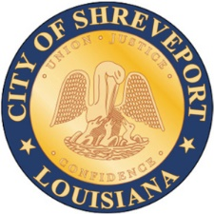
Hold Harmless Agreement
City of Shreveport, Louisiana, Sidewalk Café Permit

WITNESSETH

WHEREAS, the undersigned has made application for a Sidewalk Café Permit in the City of Shreveport, Louisiana, pursuant to Shreveport City Code Sec. 78-139.
NOW, THEREFORE, in consideration of the privileges and permit granted to the undersigned applicant authorizing the applicant to operate a Sidewalk Café under the guidelines set forth in Shreveport City Code Sec. 78-139 and the Sidewalk Café Permit Application, the undersigned applicant hereby agrees to indemnify and hold harmless the City of Shreveport (“CITY”), the Shreveport Downtown Development Authority (“DDA”), the Shreveport Caddo Metropolitan Planning Commission (“MPC”), their elected officials, officers, employees and agents from and against any and all claims, demands, lawsuits, judgments and sums of money to any party accruing against the CITY, the DDA, the MPC, along with their elected officials, officers, employees, and agents for loss of life or injury or damage to persons or property arising out of or in connection with the operations, licensing or permitting of the undersigned.
The undersigned applicant, hereby also agrees that they understand and expressly assume all the risk of operating and conducting business under the Sidewalk Café Permit.

THE UNDERSIGNED APPLICANT, understands and acknowledges that he/she is responsible for any and all damages in all circumstances created by outdoor furniture, table umbrellas, and/or equipment in the permitted sidewalk café area and agrees to indemnify and hold harmless the CITY, the DDA, the MPC and their elected officials, officers, employees, and agents for any claims or lawsuits to persons or property as a result.
THUS DONE AND SIGNED this ____ day of ___________, 20___, in the presence of the two undersigned witnesses.
WITNESSES: |  |  | SIDEWALK CAFÉ APPLICANT
 |  |  | Business Name:
 |  | BY:
Printed Name: |  |  | Printed Name:
 |  |  | Address:
Printed Name:

Exhibit D Furniture Samples
Tables must be functional and well maintained. Tables may be any shape but may not be over 36 inches in height. Smaller tables are encouraged as they provide more layout flexibility. Table edges and corners should be rounded and safe for passing pedestrians.
Encouraged materials: metals, finish grade woods, sturdy recycled materials.
Discouraged materials: breakable plastic, unfinished lumber, interior furnishings.

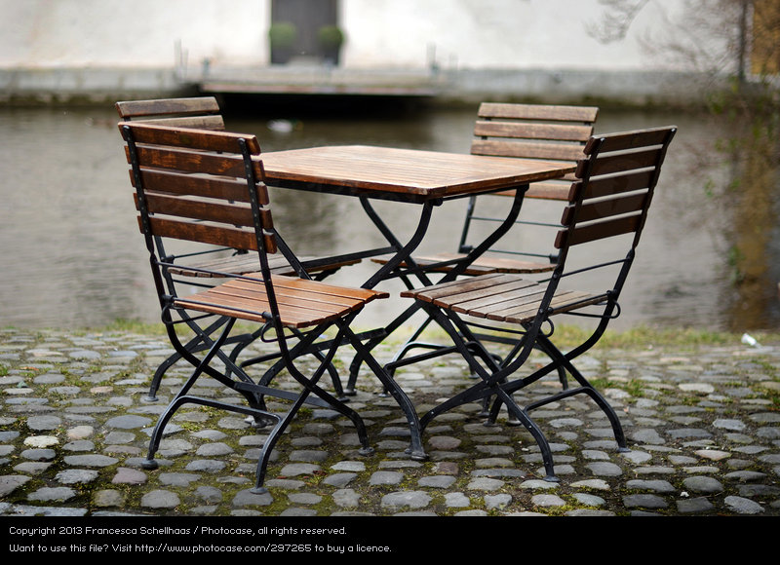

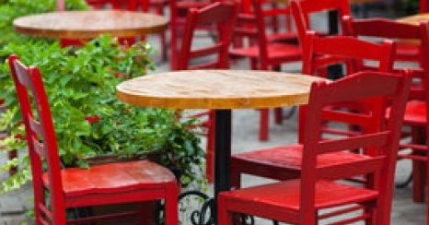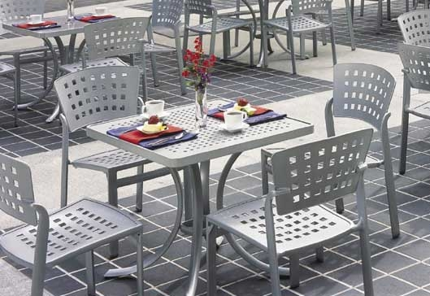
Examples of acceptable sidewalk café furnishings, which may be a variety of shapes, materials and colors.

Exhibit D Furniture Samples
Discouraged Types

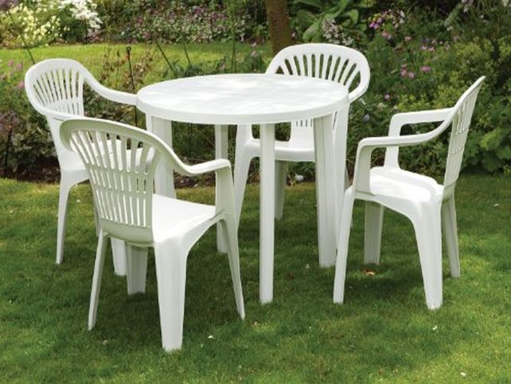

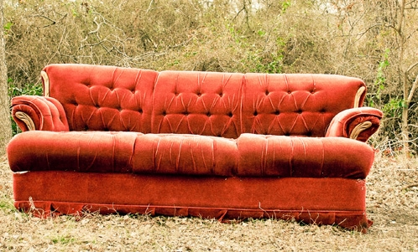

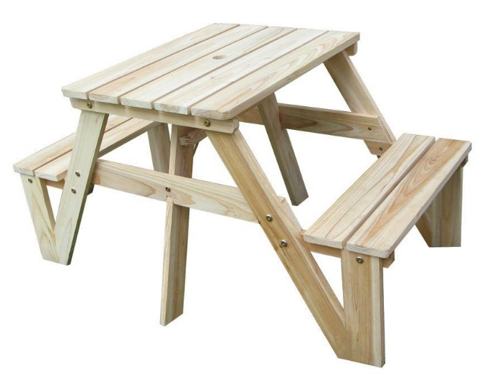

EXHIBIT A Sample
(There are some free CAD drawing programs that you can use at https://www.thoughtco.com/top-free-cad-packages-485330 )
All Drawings are required to be 1:8 scale

